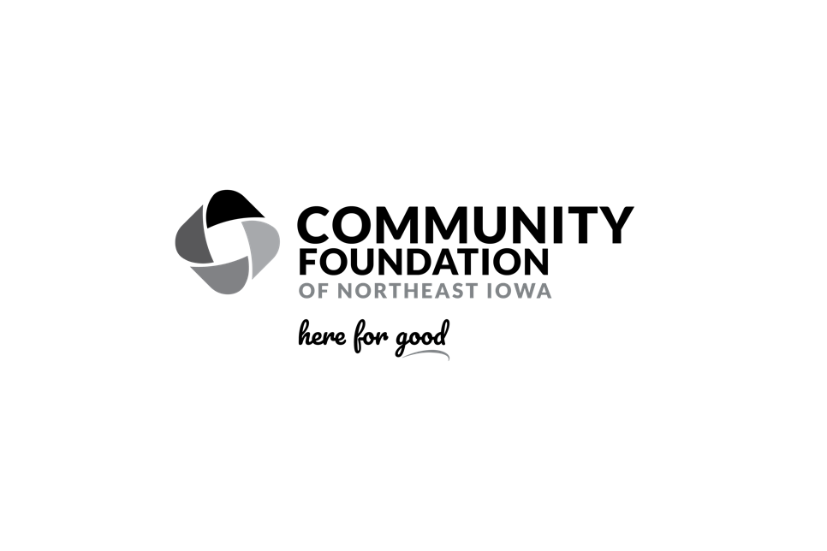
Promoting Your Nonprofit Endowment Fund
Thank you for partnering with the Community Foundation of Northeast Iowa to strengthen your organization today and for future generations through your nonprofit endowment fund. Below you will find language to help you promote your fund. If you have questions about fund language, finding the link to your fund’s online giving page, or any other topics related to promoting your fund, please contact or marketing department at marketing@cfneia.org.
Letter/Newsletter Language
Subject: Create a Lasting Impact – Support Our Endowment Fund
Dear [Donor's First Name],
At [Your Nonprofit’s Name], we are committed to serving our community now and for generations to come. A crucial part of sustaining our mission is the [Nonprofit Agency Endowment Fund Name]. This permanent fund, managed by the Community Foundation of Northeast Iowa, provides a reliable source of income that supports our work every year, forever.

What is a Nonprofit Endowment Fund?
A nonprofit endowment fund is a permanent fund that is professionally invested, allowing it to grow over time. The returns generated from these investments provide our organization with a steady stream of income, helping us to continue our mission and meet evolving community needs.

Your Gift Creates a Lasting Impact
Your donation to the [Nonprofit Agency Endowment Fund Name] is a gift that keeps on giving. Whether you contribute cash, stocks, or a planned gift through your will, you are making a forever gift that will impact lives for generations.
To give online, visit [Insert Donation Link] or contact [Insert Organization Contact Information]. You can also mail checks made payable to [Fund Name] to the Community Foundation of Northeast Iowa at 3117 Greenhill Circle, Cedar Falls, IA 50613.

Increase Your Impact with Endow Iowa
Did you know that your gift to the [Nonprofit Agency Endowment Fund Name] may qualify for a 25% state tax credit through Endow Iowa? This additional tax incentive is available on a first-come, first-serve basis, so giving early in the year maximizes your chance of receiving this benefit.
Learn more about Endow Iowa and how your gift can go even further at cfneia.org/endowiowa.
Thank you for your continued support and for investing in the future of [Your Nonprofit’s Name]. Together, we can make a lasting difference.
With gratitude,
Website Language
Support our mission for generations to come by giving to the [Nonprofit Agency Endowment Fund Name]. Managed by the Community Foundation of Northeast Iowa, your gift creates a permanent source of income that sustains our work year after year. Plus, eligible gifts may qualify for a 25% state tax credit through Endow Iowa.
Learn more and give today: [Insert Donation Link]
Social Media Post Language
Make a lasting impact! Your gift to the [Nonprofit Agency Endowment Fund Name] helps sustain our mission forever. Learn more and give today: [Insert Donation Link] #Endowment #ForeverImpact #CommunitySupport
Did you know? A gift to our endowment fund can qualify for a 25% state tax credit through Endow Iowa. Your support goes further! Donate now: [Insert Donation Link] #EndowIowa #TaxCredit #GiveBack
Ensure our mission continues for generations. Support the [Nonprofit Agency Endowment Fund Name] and create a permanent source of income that impacts lives year after year. Give now: [Insert Donation Link] #LegacyGiving #CommunityImpact #NonprofitEndowment

